Answer the following questions:

Be sure to provide **screenshots** along with your **explanations**.

1. Include a **screenshot** of an interesting design that your Logo app made and a **screenshot** of the code that created it. Press the power button and volume down at the same time to take a **screenshot**.

**Include this image and code in your write-up document, below.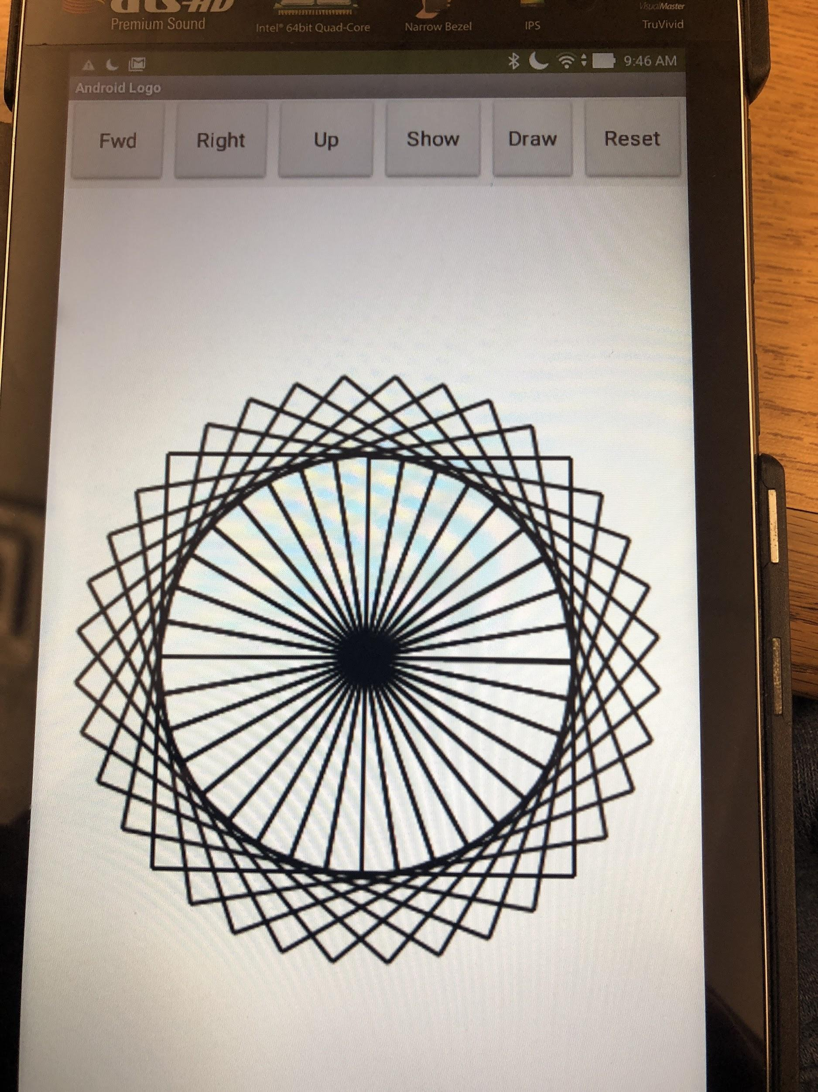**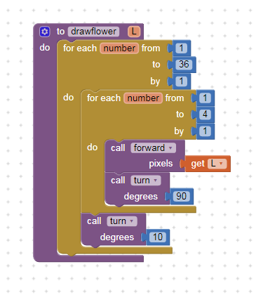

The lesson here is that our choice of abstractions, in this case, the use of parameters in our Logo commands, affects the kinds of problems we can solve and how we solve them. That is, our choice of abstractions have an enormous impact on our algorithms. In addition, procedural abstraction (both with and without parameters) makes algorithms easier by raising the level of abstraction.

2. Describe in your own words, with a specific example from Logo, how our choice of abstractions (commands) in this lesson provides us with the ability to solve problems that couldn't be solved with the abstractions (commands) used in Logo Part 1.

**Answer**

|  |
| --- |
| **The choice of commands in this lesson gives us the ability to procedurally create shapes allowing for the code to be much simpler but at the same time make any shape we want to make in a few easy steps. The abstraction would not have been possible in Logo part 1 because we were unable to change the radius of the turn that the android made.** |